# Login in: <http://garland.maps.arcgis.com/home/index.html>

# Data under: <https://maps.garlandtx.gov/arcgis/rest/services/OpenData>

# Open Data: <http://data-garland.opendata.arcgis.com/datasets?t=>

# Click Content.

# 

# Click add item 🡪 From the web

## 

# Get URL for the item.

## Open <https://maps.garlandtx.gov/arcgis/rest/services/OpenData>

## 

## Open OpenData/City_Services (MapServer)

## There are two layers

## 

## Open [EWS Residential Trash/Brush](https://maps.garlandtx.gov/arcgis/rest/services/OpenData/City_Services/MapServer/5), the path of it with be the URL we need.

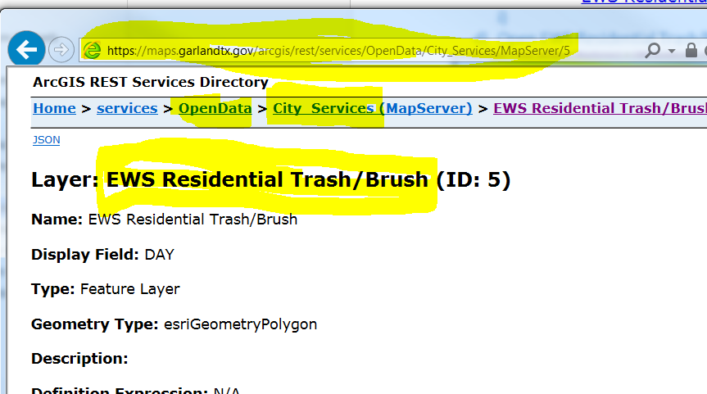

# Put all the highlighted information to the page in step 4), then click Add Item (use comma to separate tags).

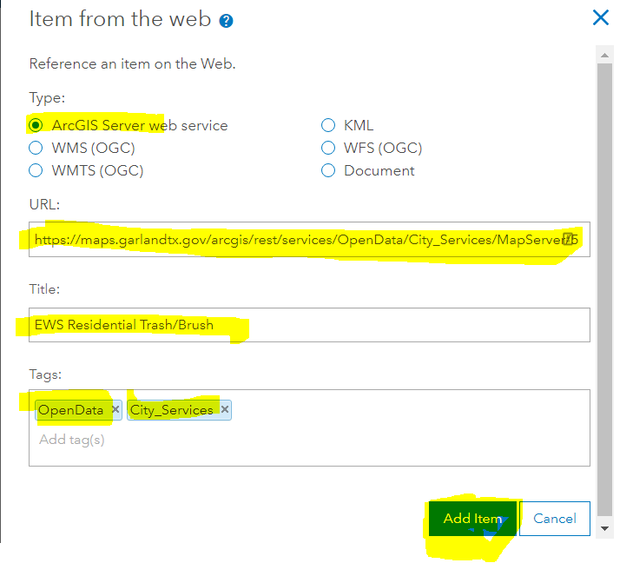

# Waiting for data to be added. Then click Share.

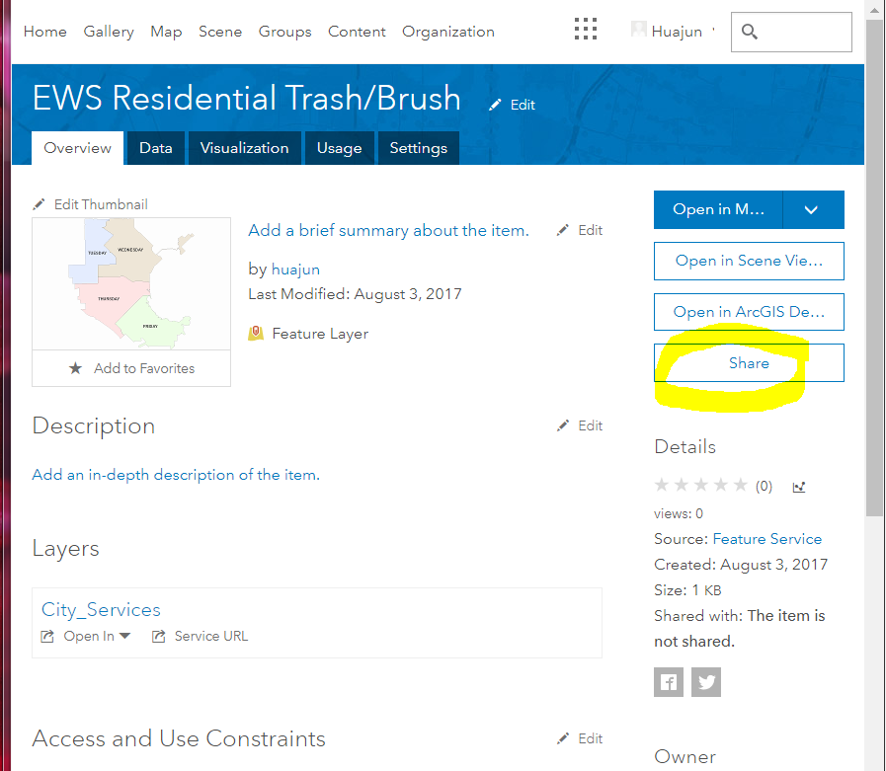

# Share the item with following groups. Then click OK.

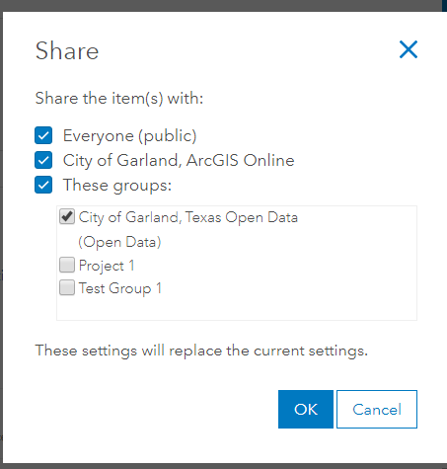

# Now you should be able to see the data under open data portal

<http://data-garland.opendata.arcgis.com/datasets?t>=

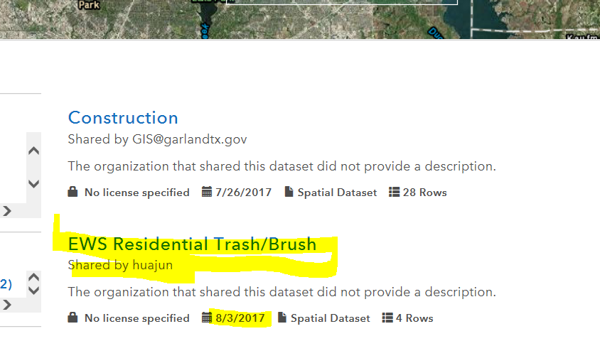

# Repeat step 2) to 7) for all the other items in step 3)

There should be 19 items need to be added, including EWS Residential Trash/Brush layer.